Question 1

Part A

function sumArray(arr) {

    let sum = 0;

    arr.forEach(element => {

        sum += element;

    });

    return sum;

}

function productArray(arr) {

    let product = 1;

    arr.forEach(element => {

        product \*= element;

    });

    return product;

}

let arr = [1, 2, 3, 4, 5];

console.log("Sum of array: " + sumArray(arr));

console.log("Product of array: " + productArray(arr));

Output:

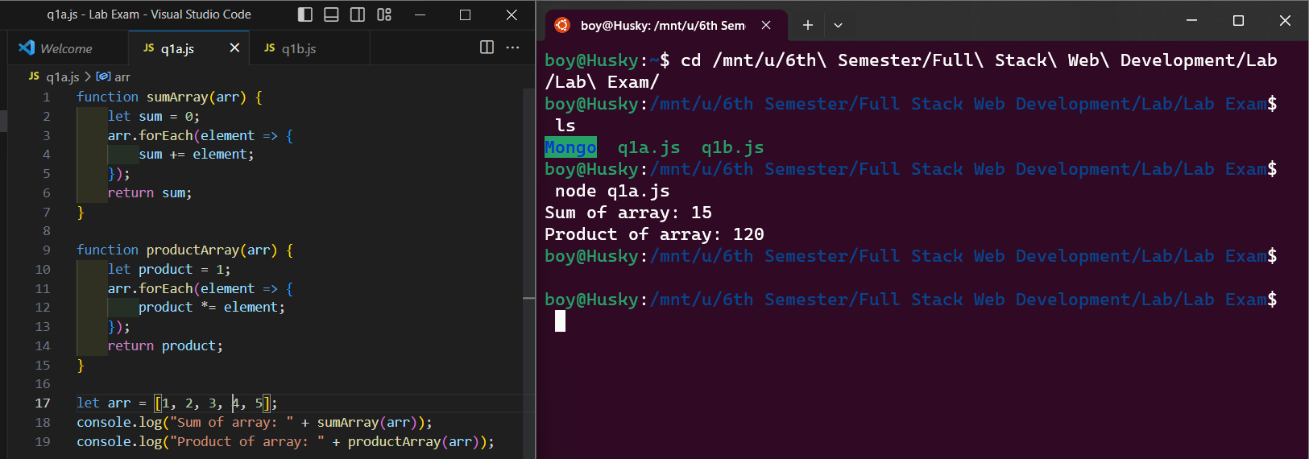

Part B

import React, { useState } from 'react';

function useCounter() {

    const [count, setCount] = useState(0);

    const increment = () => setCount(count + 1);

    return [count, increment];

}

function Counter() {

    const [count, increment] = useCounter();

    return (

        <div>

            <p>Count: {count}</p>

            <button onClick={increment}>Increment</button>

        </div>

    );

}

export default Counter;

Part c

./src/components/NavBar.js

import React from 'react'

import { Link } from "react-router-dom";

import './navbar.css';

import { Navbar, Container, Nav } from 'react-bootstrap';

export default function NavBar() {

    return (

        <Navbar bg="light" expand="lg">

            <Container>

                <Navbar.Toggle aria-controls="basic-navbar-nav" />

                <Navbar.Collapse id="basic-navbar-nav">

                    <Nav className="me-auto">

                        <Link className='flex' to="/">Home</Link>

                        <Link className='flex' to="about">About</Link>

                        <Link className='flex' to="contact">Contact</Link>

                    </Nav>

                </Navbar.Collapse>

            </Container>

        </Navbar>

    )

}

./src/pages/About.js

import React from 'react'

export default function About() {

return(

<div>

  <h1>About Page Hamza Umer 200789</h1>

</div>)

}

./src/pages/Contact.js

import React from 'react'

import {Form, Button} from 'react-bootstrap';

import { useNavigate } from 'react-router-dom';

export default function Contact() {

  return(

    <div>

      <h1>Contact Page Hamza Umer 200789</h1>

    </div>)

  }

./src/Home.js

import React, {useEffect, useState} from 'react'

import axios from 'axios';

export default function Home() {

  return (

    <div>

      <h1>Homepage Hamza Umer 200789</h1>

    </div>

  )

}

